Instructions on how to obtain the TCN

- Upon the completion of fingerprinting you will be issued a receipt with a UEID number.
- Return this receipt to your employer.
- You will also receive an e-mail confirmation (providing an e-mail address when you schedule your appointment is recommended). This e-mail should also be forwarded to your employer.

- The receipt contains a UEID unique to the fingerprints. The UEID will always be 10 characters long, and will always have a prefix of “UZNJ” for New Jersey submissions. The remaining 6 characters will be alpha or numeric, randomly assigned by the system.

- Employers will visit https://uenroll.identogo.com and click on “Check the status of your service”

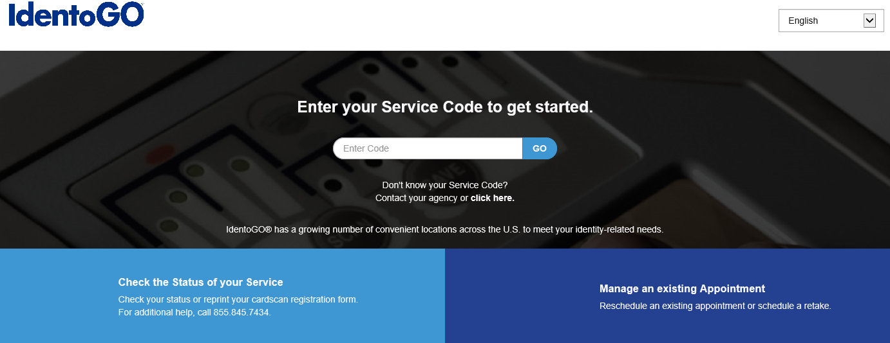

Click on the “UE ID/ Date of Birth” method

You will be prompted to enter the UE ID and date of birth.
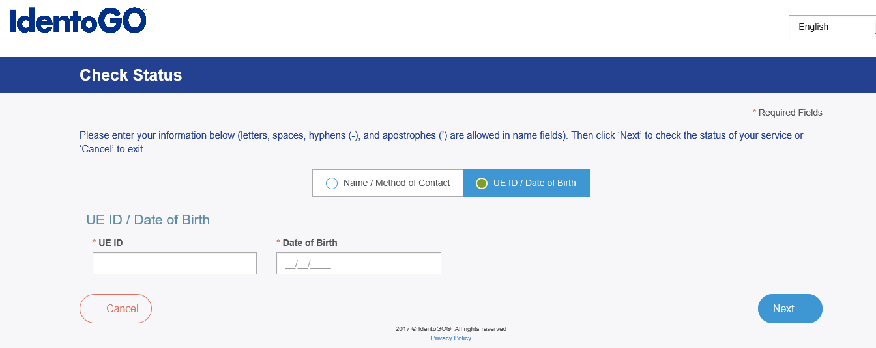
  - You will then be given the status of the fingerprinting process and a TCN number.
  - Retain the TCN Number and the fingerprint date for your records
  - Results of fingerprints can be obtained by visiting the DHS Fingerprint Approval Retrieval Application
  - (FARA) at https://www.state.nj.us/humanservices/staff/opia/cfu/fara.html
  - Fingerprint applicants are not authorized to access results from FARA- only agency personnel should access results from FARA
  - Enter the TCN (in place of the PCN, the Contributor case #, and the Fingerprint Date

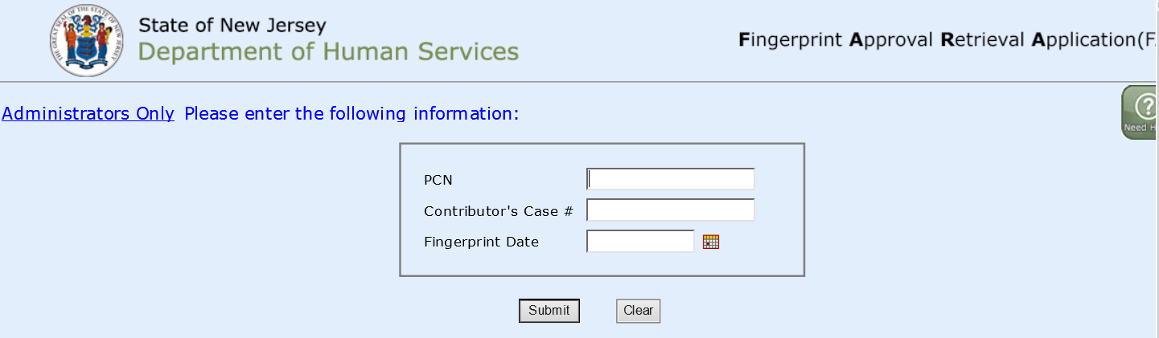
A cleared letter will be available for printing.

